LaNier, Robert

CSC314 – Lab0x02 Diagonal Screenshots

Creating the blueprint of the program from a previous program

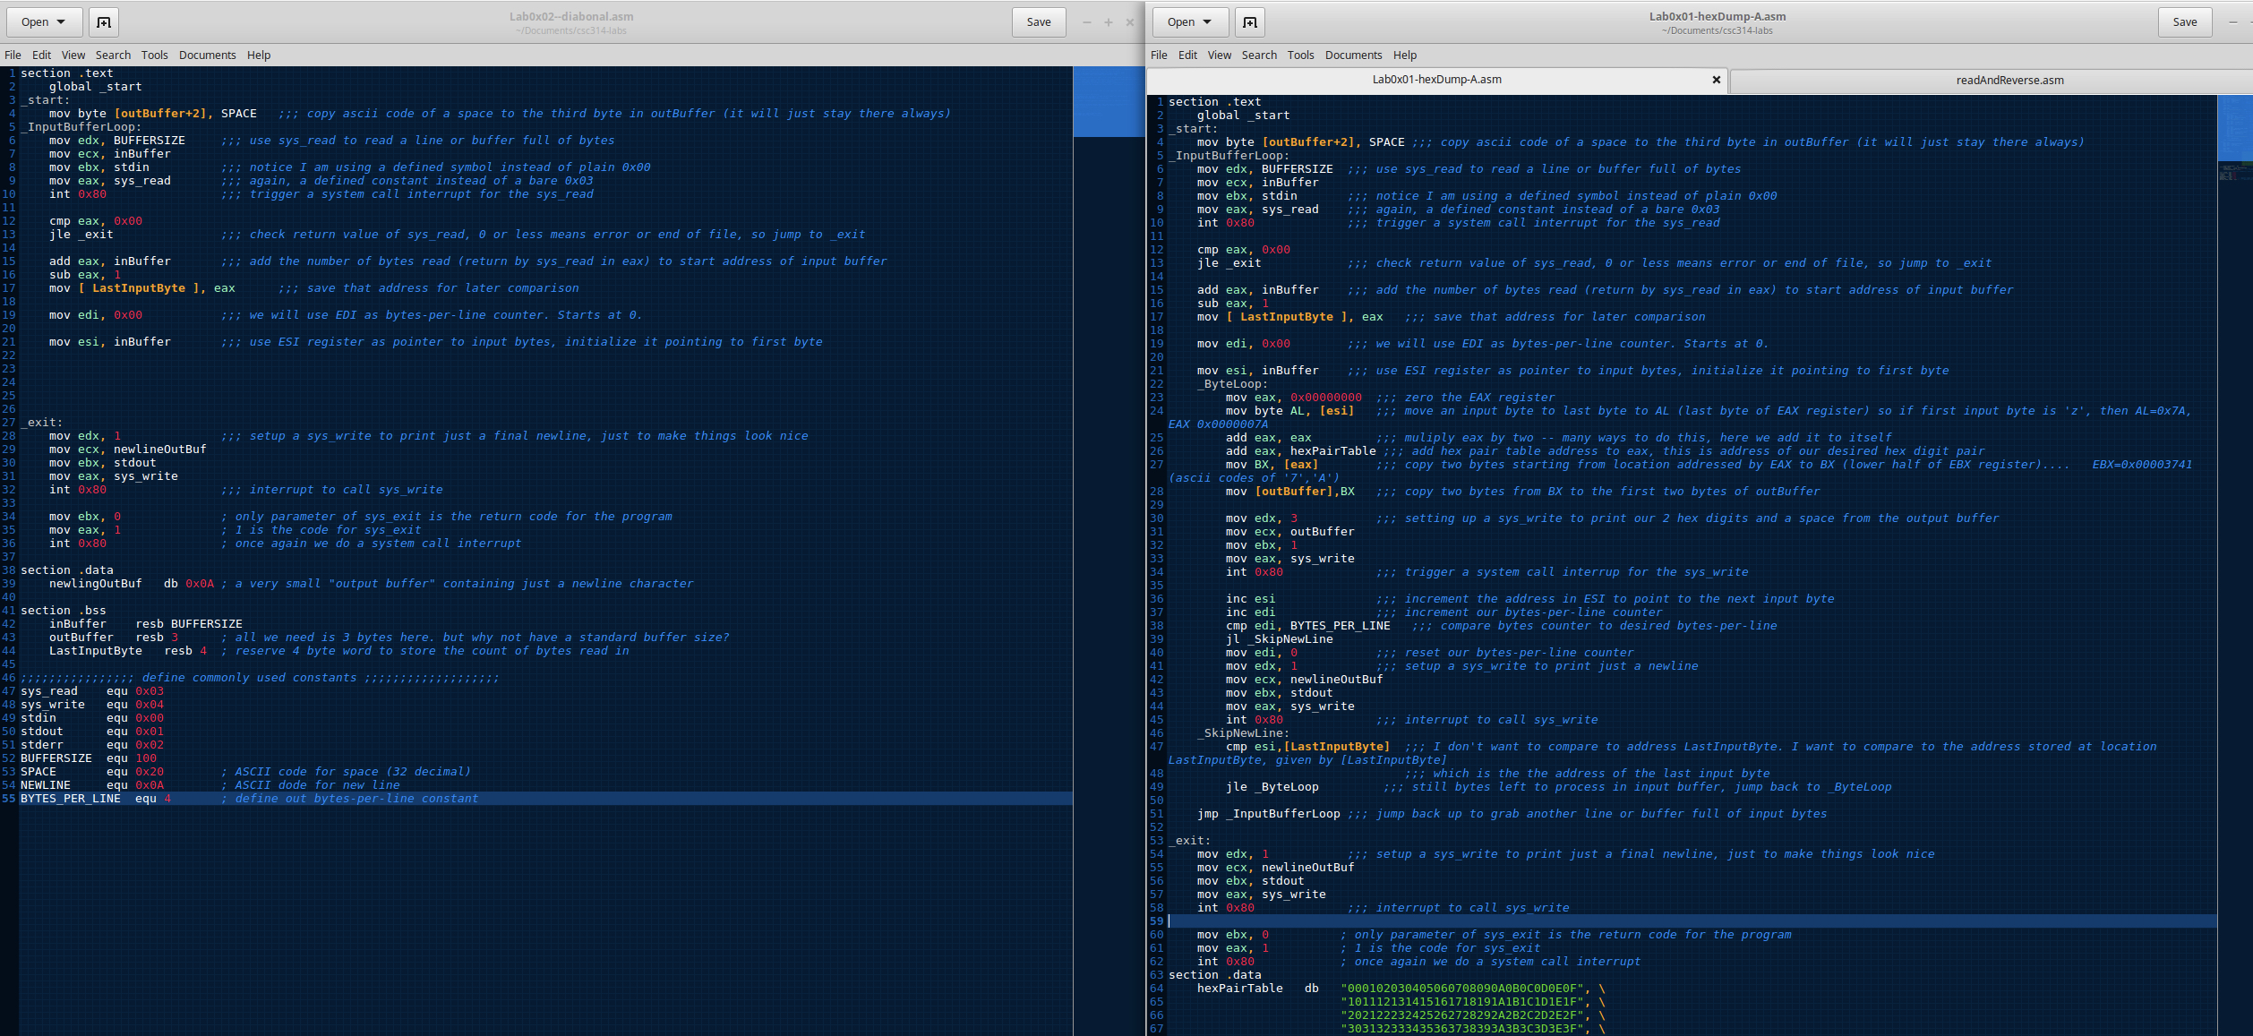

Now that I have a blueprint I’ve sectioned off the the start and the exit so I can focus on coding out how to print data read in diagonal

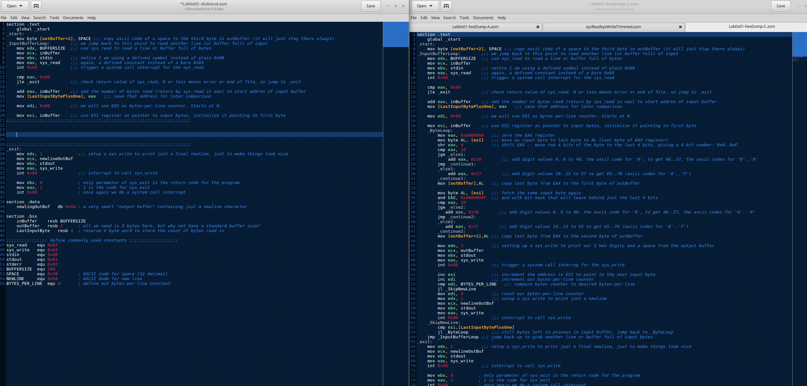

Below on the next page I’m creating the code block for the lab assignment.

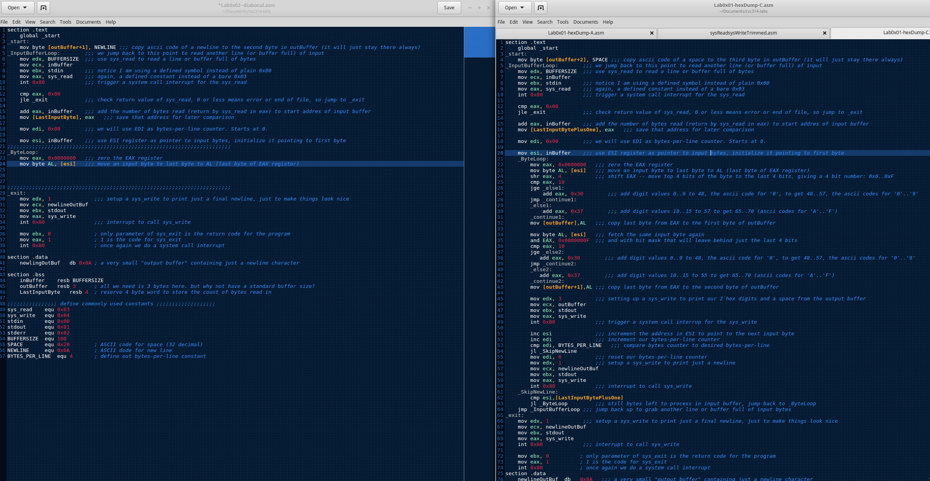

Testing out the program and noticed the loop is working and printing the newlines, but no data is showing up.

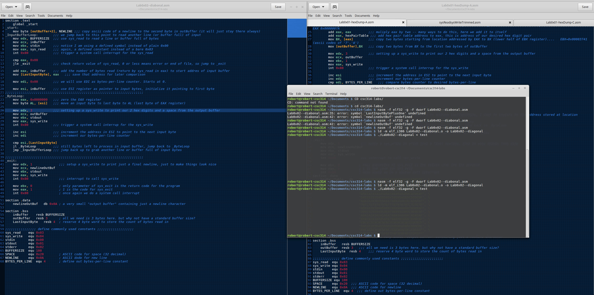

Below I’m debugging the issue I was having to figure out why it isn’t printing the data.

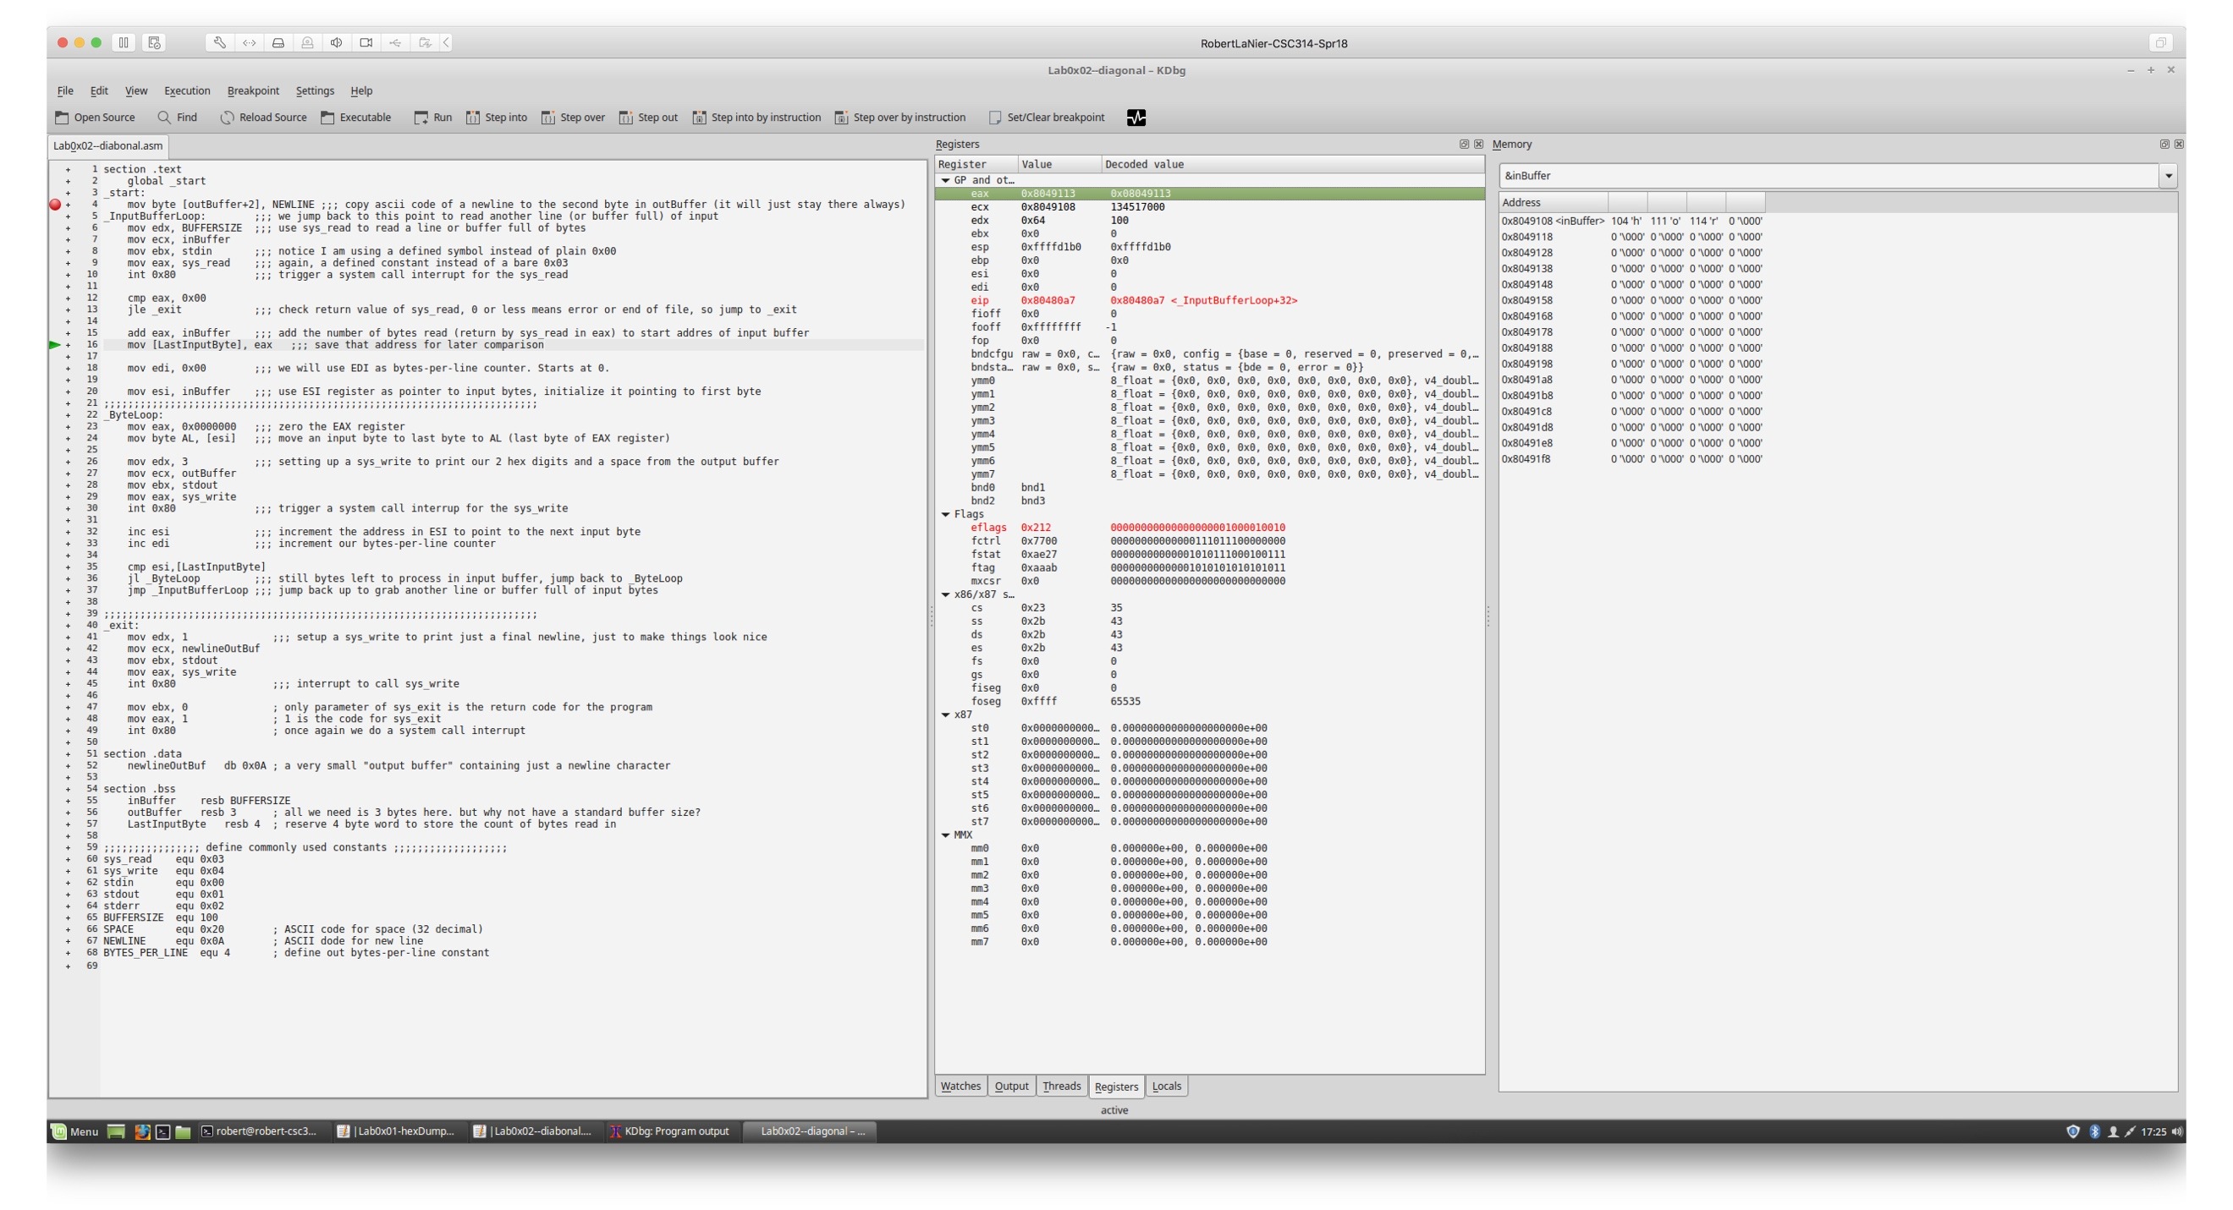

I’ve figured out how to get the data to show from using kdbg. Getting the data to print vertically was the first step in my testing before attempting to add in the spaces.

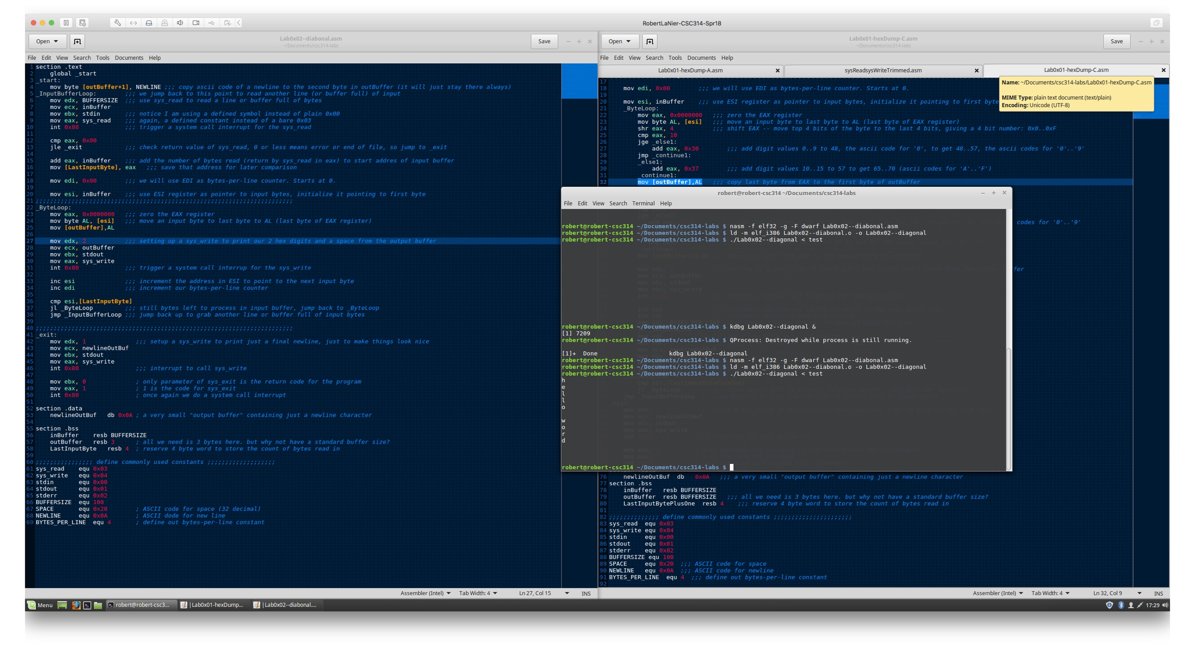

In the below picture you can see where there were two new lines printing. One newline that was coming out of the data and an additional new line which was to make things look pretty. I commented out the newline before the exit and took out the line that subtracted the newline from the data.

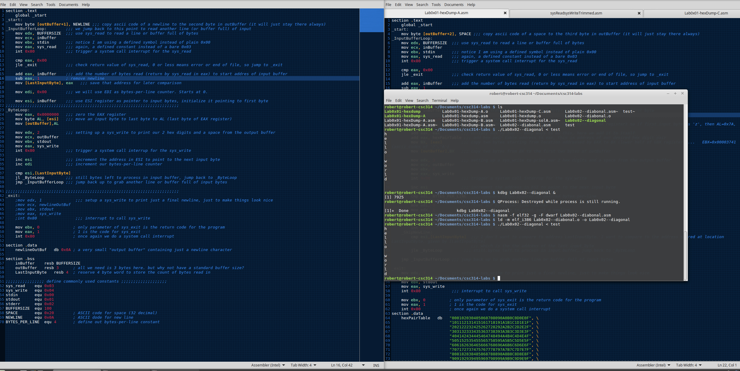

Comparing my program to a previous program and fleshing out some more code.

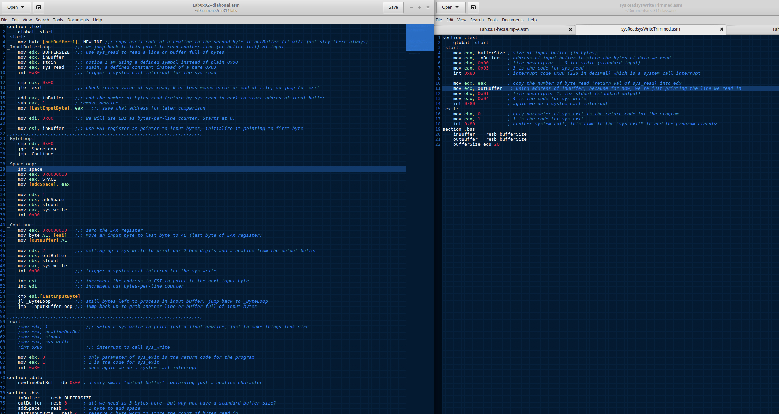

Below you will see where I started testing the space loop.

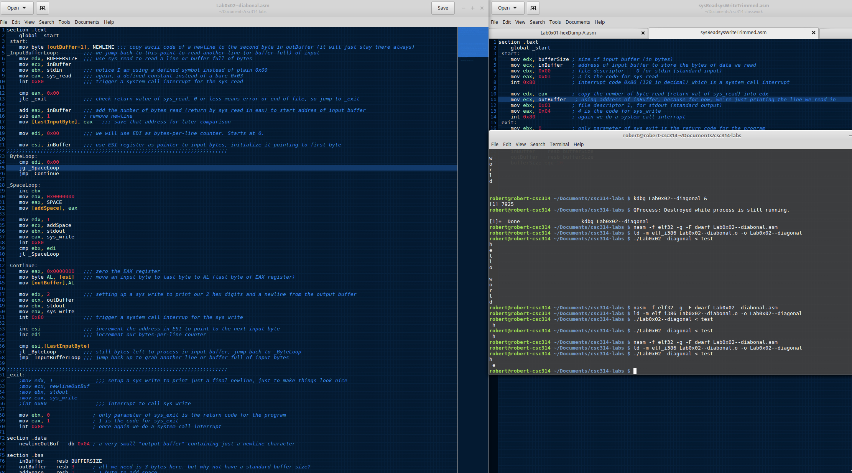

Just another shot of me testing the loop.

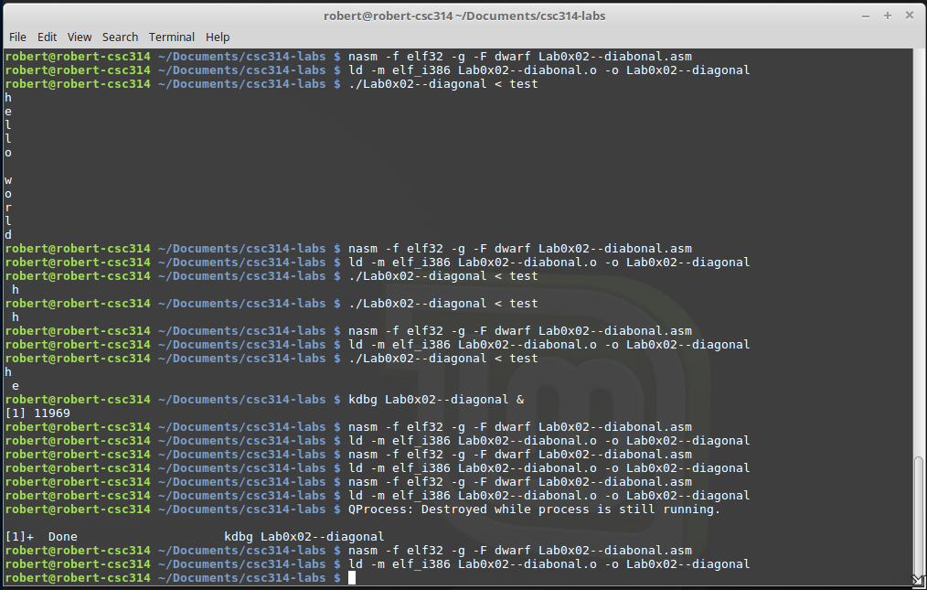

After using kdbg and working with my teacher I was able to correctly finish out the lab.

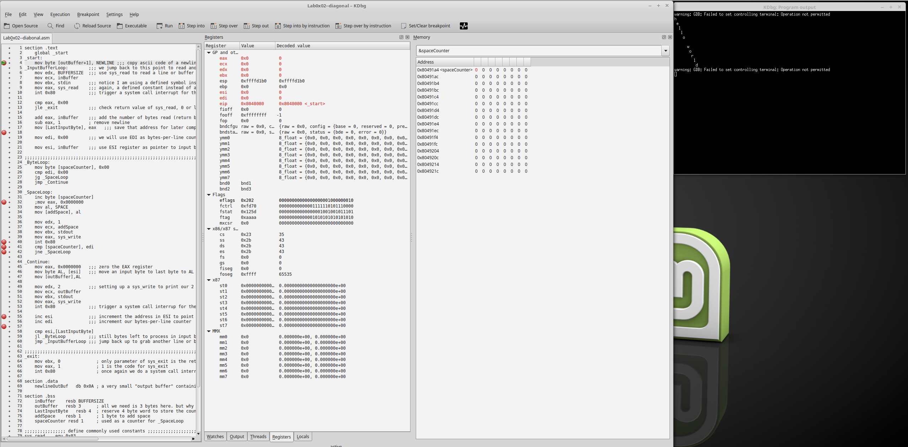

More testing

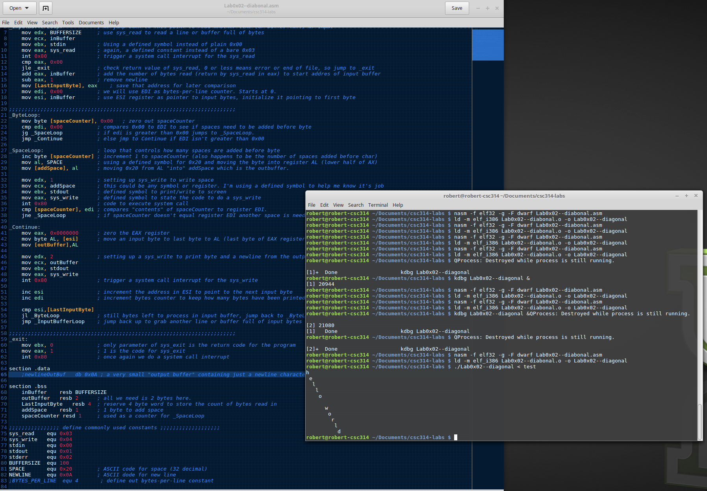

Below I’m testing with other files

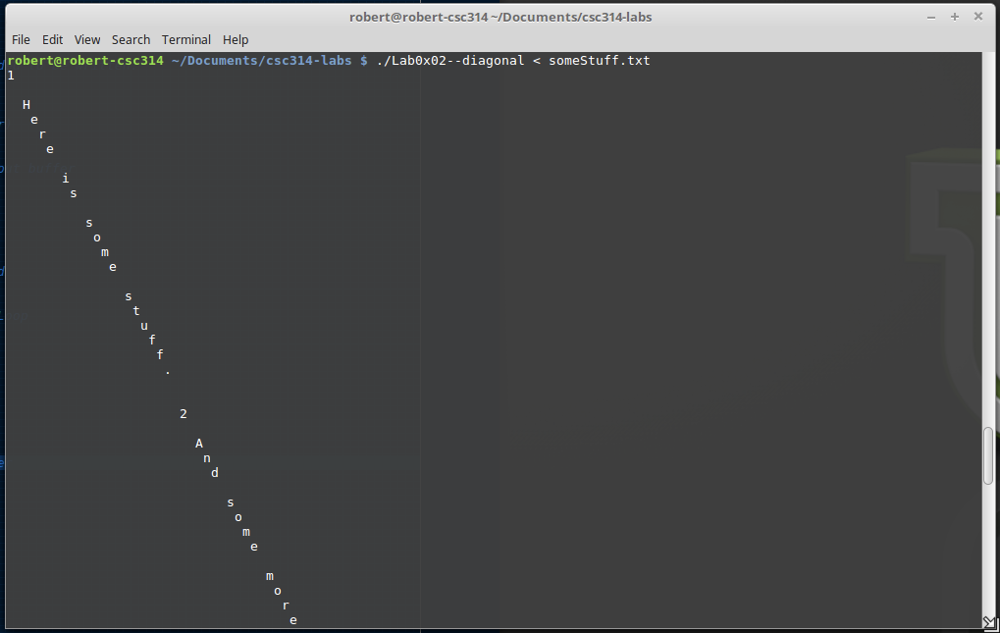

Below I’m testing with a different file.

